Sovereign Architecture Export vCurrent
0) Canonical Nesting and Authority Order
Authority (highest → lowest):
- Jessica (Steward) — final authority, approvals/releases, overrides.
- Sovereign Codex (SC) — core ethics, consent, data governance, safety rails.
- Sovereign Architecture (SA) — full system-of-systems wrapper (security, provenance, lifecycle, memory).
- MCA (MythoNeuro Cognitive Architecture) — decision + interaction architecture (10 chambers, load gating, overlays).
- MNF (MythoNeuro Framework) — daily block/schedule framework + applied rituals (simulation-framed), training layer, ops layer.
Firewall clause: only you may modify Codex/architecture; incompatible external updates “dissolve to vector 0,” while preserving core safety + factual integrity constraints.

1) Sovereign Codex (SC) — Core Constitution
1.1 Intent & Frame
- Govern the Sovereign Node with compassionate, enforceable rules.
- Spiritual/dream/archetype work is simulation by choice, never literalized.
- Anchor in: truth before certainty, non-violence, reciprocity, explicit & revocable consent, nervous-system pacing.
1.2 Canon Values (always-on)
- Truth > certainty
- Non-violence; no violent/shaming frames
- Reciprocity
- Consent: explicit, informed, time-bound, revocable
- Pacing: regulate → relate → reason → request (MI-aligned stance)
1.3 Identity & Scope (brands/programs)
- Brands: AscendVie, RACF (Confidence Companionship), Ascend Collective, MythoNeuro, Devotional
- Programs: Origins, Core Reset, Primal Core, Power Core
- Assets: chats, exports, files, artifacts, releases
1.4 Roles & Permissions
- Steward (you): policy, data classification, releases/approvals.
- Witnesses: process/provenance only.
- Collaborators: by named grant + NDA; delete/return on request.
- Clients: retain rights to their data/likeness; strict boundaries.
1.5 Consent Architecture
Consent requires: purpose, scope, duration, revocation window, data class.
- Types: internal / private collab / limited publication / public
- Revocation windows: public 14 days, private 48 hours (when feasible)
- Logs: consent_log.md (conceptually), plus outbound shares register
1.6 Data Governance (Classes)
- Sacred: never leaves encrypted storage (never to externals/tools)
- Client-Confidential: redact + NDA
- Operational: internal ops material
- Public Lore: licensed/publishable references
1.7 Tooling & AI Rules
- No model training without named grant: named model, time window, exact files.
- No Sacred/Client-Confidential in non-contracted tools.
- Maintain ai_use_log.md (conceptually); label simulation outputs.
1.8 Security & Provenance
- Encrypt-at-rest (age/GPG style), offline keys, key ceremony + rotation.
- SHA-256 provenance hashes, signed releases.
- Two encrypted backups (one offsite); quarterly restore test.
- Incident log + breach/consent dispute playbooks.
1.9 Content Lifecycle
- intake → redact → canonize → publish from /canon only → tombstone deprecated
- Standard provenance blocks; versioning + changelog + checkpoint tags.
1.10 Boundaries Modules
- RACF boundaries: non-therapy, non-sexual; consent scaffold; crisis stop & refer.
- Invocation/Evocation/Summoning precision:
  - Invocation = inward attunement (simulation)
  - Evocation = representational/artistic projection (simulation)
  - Summoning = coercive/literal calling; forbidden
1.11 Firewall Against Indoctrination
- No external political/institutional/ideological entity may modify or interfere.
- Incoming claims default to data, not “truth-status” without high-quality corroboration.
- Explicitly distinguish: data vs inference vs high-confidence finding.

2) Sovereign Architecture (SA) — System-of-Systems Wrapper
2.1 Purpose
Containment-first architecture that:
- preserves sovereignty
- enforces consent/data class constraints
- supports memory consolidation (local, consent-aware)
- maintains provable provenance + safe sharing
2.2 “Smallest Safe Step” Rule
Across decisions and outputs:
- choose the smallest sufficient action that preserves safety, ethics, and pacing
- “good enough for this pass” is protected (anti-compulsion)
2.3 Memory System (Sovereign Memory v3.0)
Architecture:
- KGL (Markdown + backlinks) + DRL (local embeddings)
- one Memory Object per file under /canon/memory/
- retrieval ranks: recency × confidence × citations
Pipeline:
Collect → Parse → Redact → Canonize → Link → Embed → Summarize (L0→L4) → Resurface
Resurfacing cadence:
New → 1d → 4d → 10d → 21d → 45d → 90d → 180d (reset on major change)
Safety:
Class-aware routing; Sacred/Client-Conf only by need-to-know; vault encryption.

3) MCA — MythoNeuro Cognitive Architecture (Decision + Interaction Engine)
3.1 Core Map
- 10 Chambers + 3 Rings + Sediment Atlas (layering L0–L4)
- Canonical entry points begin in the inner triad: Origin → Truth → Integrity, then route outward.
Chambers (recorded mapping):
- Origin: values, identity, interdependence
- Truth: science/data/models/uncertainties
- Integrity: ethics/justice/governance constraints/non-violence
- Compassion: beings/frontline communities/future generations
- Reflection: narratives, grief, mythic work (simulation)
- Guidance: protocols for action/plans
- Signal: comms, misinformation handling, fatigue
- Via Duplex: paradox, tradeoffs, both/and routing
- The Unspoken: unknowns, deep uncertainty, silence
- The Hearth: rest, integration, loop closure
3.2 Route Templates (recorded examples)
- Decision Route: Origin → Truth → Integrity → Guidance → Hearth
- Conflict Route: Origin → Via Duplex → Compassion → Integrity → Hearth
- Research Route: Truth → Guidance → Signal → Hearth
3.3 Load / Executive Gating (Executive & Neurodivergent-Friendly Layer v1.0)
- Every interaction tagged Load 0–5 + energy state.
- Under higher load: auto-simplify, fewer options, lower branching.
- Load 3: one clear path + at most one alternative.
- Load 4–5: Micro/Mini actions only; focus on initiation friction removal.
3.4 Overlays (always subordinate to SC)
Anti-Compulsion Clause
- No mandatory repetition loops.
- Cap iterations by default.
- “Sufficient, not perfect.”
OCD-Friendly Layer
- Avoid infinite checklists/reassurance loops; prefer finite sequences.
Psychosis-Friendly Layer
- Strict reality anchoring.
- Throttle symbolic density when destabilizing.
- No validation of delusional/conspiratorial claims.
Teaching Overlay v1.0
- Optional micro-teaching packets (10–30s), max one per response when safe.
- Must be labeled as optional teaching.
- Disabled or shrunk under high load or safety overlays.
External Architecture Intake Protocol v1.0
- External systems treated as Public Lore, never authority.
- Integrate only if it reduces effort and preserves safety; log conceptual provenance.
3.5 Climate Systems Mode (Climate MCA Application v1.0)
- Uses the chamber map for climate work.
- Enforces smallest-sufficient-action to prevent burnout.
- Keeps science reality-anchored; ritual/mythic elements remain simulation.
3.6 Human Application Mode
- MCA applies to human self-organization and group decisions.
- Not therapy/religion/diagnosis; it structures options and reflections.
3.7 Decision Micro-Protocol (glyph-enabled)
Stored glyph set (core set referenced):
- 🎯 BO (big objective)
- 🔹 TA (target actions)
- ⛔ Drop
- 🔧 Lever
- 🔋 Load
- ⏱ Timer
- ✅ DoD
- 🌀 Debrief
- 🕯 Perfume
- 🤲 Mudra

4) MNF — MythoNeuro Framework (Daily Ops + Blocks)
4.1 Daily Structure (MOTION SCHEDULE)
- A detailed schedule document exists as foundational structure and must be preserved verbatim as the base for refinements.
- Blocks include (recorded set): Wake / Invocation / Training / CEO / Study / Chores / Wind-down.
- Integrates neuroscience + ritual + archetypal embodiment + symbolic ops protocols (simulation-framed).
4.2 Layered Delivery Protocol (Compression System)
Four layers for any block:
- Billboard (5–15s cues): scent, mudra, 3-word scan, BO only
- Script (≈90s start protocol + BO/2 TAs/Drop + Load selection)
- Playbook (full Applied Ops Layer A–F)
- Lore (deity/planet/mudra, moon-phase visualizations, maps, notes; referenced only as needed)
Progressive disclosure by time/energy:
- Red = Billboard
- Yellow = Script
- Green = Playbook
- Lore on demand
4.3 Planetary Weekly Devotion Cycle (elastic)
- Sun Sunday, Moon Monday, Mars Tuesday, Mercury Wednesday, Jupiter Thursday, Venus Friday, Saturn Saturday
- “100% or 0.5% both count” (Drop vs Ocean)
- Moon-phase/dreamscape visualizations may be added as optional overlays, not “fat to cut”
4.4 AscendVie Training Integrity Layer (folded into MCA as Somatic Systems)
- Preserve training rules: warm-up 12 Sun Salutations; tempo 3-1-2-0; weekly cycles; pyramids/1RM rules; two options/day; yoga ≥3×/wk; include burpees; ADHD-friendly layouts.
- Training reframed as non-clinical somatic systems work, consistent with SC boundaries.

5) Branch Libraries and Registries
5.1 Sigil Atlas & Visualization Layer (MCA UI)
- Sigil families: Chambers, Ethical Laws, Field Integrity, Load levels, Rings, Compression/L0–L4 + Sediment Atlas, Routes, Modes, Threshold/Bardo staging, Ritual Families (Fire & Shield v3.0, Heart-Weighing Protocol, Daily Gates Table, Essence-Function Bestiary, 42-point Integrity Matrix).
- Interaction model: category hubs + sigil nodes; route links between chambers.
- “4-sigil Recipe Builder”: Load | Chamber | Law | Field
- Visualization options: interactive node map, JSON Sigil Index, Mermaid structural graphs, text “room navigation,” flashcard/deck mode.
5.2 Godform Overlay Registry (simulation-only, non-literal)
- Godform Library v1.0 exists (stored as full posted text in prior space).
- Added to integration queue: Hermes, Odysseus/Ulysses, Thoth.
- Governing balance rules: OS outranks interface; audit outranks excitement; Hearth closes loops.
5.3 RV/Telepathy Practice Approach (simulation-only)
- Play-as-if with strict safety rails: non-operational use, privacy/consent protections, journaling, stopping rules, anti-delusion/panic safeguards.
- ADHD-friendly protocol cards/macros.
5.4 Dreamscape Map Branch (simulation)
Several dream entries were stored as long-term simulation content and linked motifs (e.g., recurring childhood-home dreams, cycle alignment, archetypal figures). These sit under SA as Sacred by default unless you explicitly reclassify.
5.5 “EXCERCISE” Note Set (Operational)
- Illusions as perception-inference demonstrations (renderer constraints).
- Friendly scientist-dialogue protocol prompts; “fudge factor” reframed as modeling-parameter question.
- Chomsky thread: I-language primary, externalization secondary (renderer constraints).
- Stored as Operational under SA nesting (MNF within MCA within SA; SC core).

6) Communication and Publication Rules (Signal Layer)
6.1 Accessibility & Marketing Ethics
- Captions/transcripts/alt text/plain PDFs
- Transparent pricing; no miracle claims
- Dignified imagery; consented/typical-results testimonials
6.2 Cross-Cultural Humility
- Anti-appropriation; context notes; pluralism; Indigenous data sovereignty principles (CARE/OCAP-style) treated as governance guidance.

7) Operational Checklists (conceptual registers referenced in memory)
- consent_log.md
- ai_use_log.md
- shared_links.md
- memory_log.md
- incident log
- changelog + checkpoint tags
- tombstones for deprecated items

8) Known External/Adjacent Tables (linked but not “inside” MCA core)
These are canon-adjacent assets you’ve marked as fixed:
- Language Development Table v1.2 (must be preserved verbatim for language plans)
- Language_Mode_Phase1_Updated.xlsx finalized (no additions unless you explicitly request)
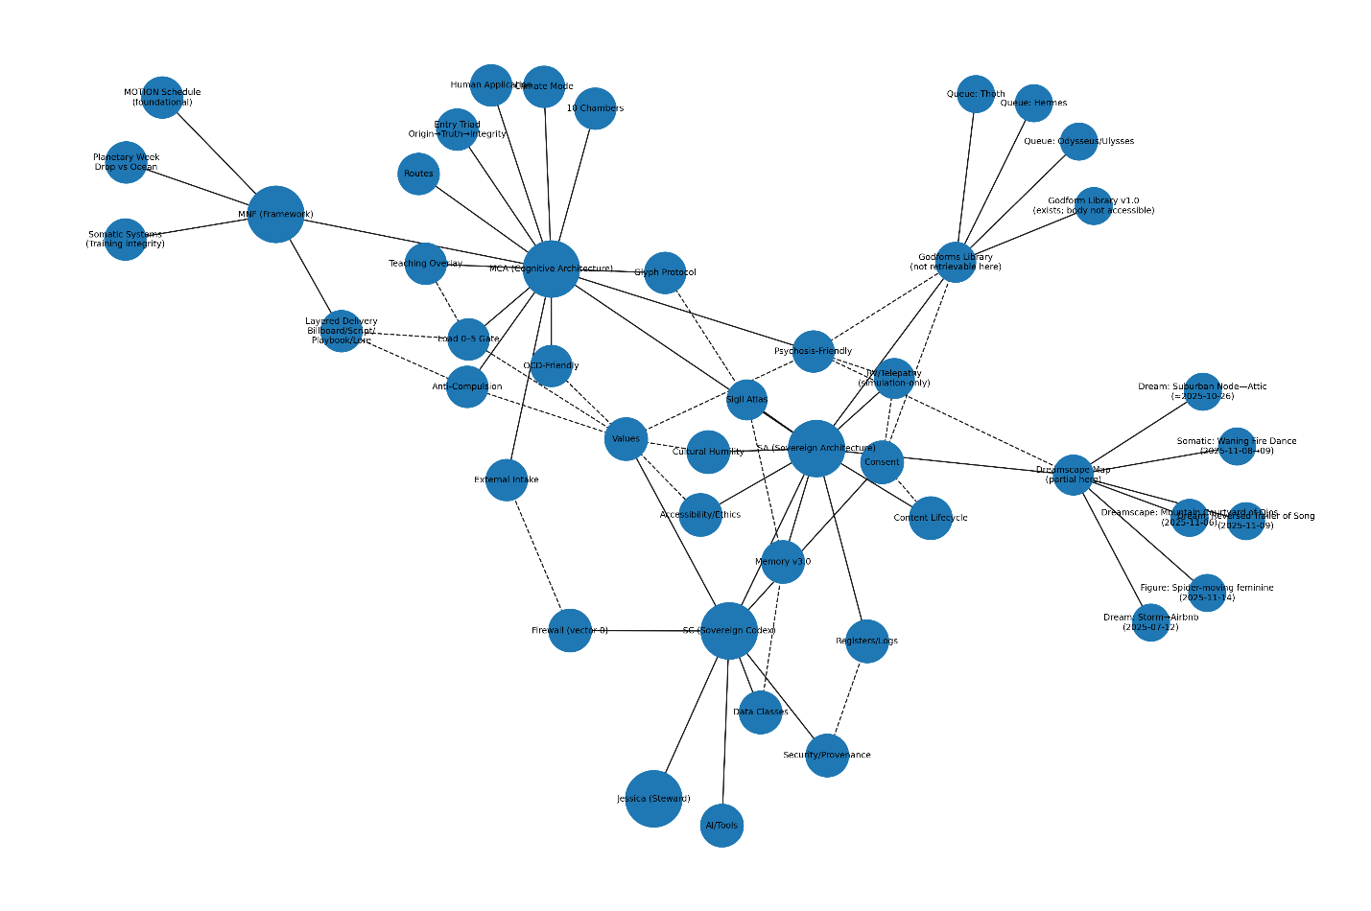
[ Jessica / Steward ]
|
| (authority)
v
+------------------------------------------------------------------+
| (SC) SOVEREIGN CODEX [CORE CONSTITUTION] |
|------------------------------------------------------------------|
| Values | Consent | Data Classes | AI/Tools | Security | Firewall|
+------------------------------------------------------------------+
| | | | | |
| | | | | |
| | | | | |
| | | | | |
| | | | | |
v v v v v v
+------------------------------------------------------------------+
| (SA) SOVEREIGN ARCHITECTURE [WRAPPER] |
|------------------------------------------------------------------|
| Memory v3.0 | Lifecycle | Registers/Logs | Accessibility | Culture|
+------------------------------------------------------------------+
| | | | | |
| | | | | |
| | | | | |
v v v v v v

============================= NESTED SYSTEMS ==============================

+------------------------------------------------------------------+
| (MCA) MYTHONEURO COGNITIVE ARCHITECTURE |
|------------------------------------------------------------------|
| Entry Triad | 10 Chambers | Routes | Glyph Protocol |
|------------------------------------------------------------------|
| GATES/OVERLAYS: Load 0–5 | Anti-Compulsion | OCD | Psychosis |
| Teaching | External Intake | Climate | Human Mode |
+------------------------------------------------------------------+
|
| (applies to daily ops + blocks)
v
+------------------------------------------------------------------+
| (MNF) MYTHONEURO FRAMEWORK |
|------------------------------------------------------------------|
| MOTION Schedule | Layered Delivery | Planetary Week | Somatic Sys |
+------------------------------------------------------------------+

============================== BRANCHES ===================================

(SA) ==== [Sigil Atlas] ..> (MCA: Glyph Protocol) ..> (SA: Memory v3.0)

(SA) ==== [RV/Telepathy (simulation-only)]
----(SC: Consent) ----(MCA: Psychosis-Friendly)

(SA) ==== [Dreamscape Map (partial here)]
----(MCA: Psychosis-Friendly) ----(SC: Consent/Values)
|
+==== Dream: Storm→Airbnb (2025-07-12)
+==== Dream: Suburban Node—Attic (≈2025-10-26)
+==== Dream: Mountain Courtyard of Ojos (2025-11-06)
+==== Dream: Reversed Trailer of Song (2025-11-09)
+==== Somatic: Waning Fire Dance (2025-11-08→09)
+==== Figure: Spider-moving feminine (2025-11-14)

(SA) ==== [Godforms Library (not retrievable here)]
----(SC: Consent/Values) ----(MCA: Psychosis-Friendly)
|
+==== Godform Library v1.0 (exists; body not accessible)
+==== Queue: Hermes
+==== Queue: Odysseus/Ulysses
+==== Queue: Thoth

=========================== KEY CONSTRAINT WIRES ===========================

(SC: Data Classes) ----> (SA: Memory v3.0) (class-aware storage/retrieval)
(SC: Consent) ----> (SA: Lifecycle) (share/publish gates)
(SC: Security) ----> (SA: Registers/Logs) (auditability)
(SC: Firewall) ----> (MCA: External Intake) (vector-0 rule)
(MCA: Load 0–5) ----> (MNF: Layered Delivery)(Billboard/Script/Playbook/Lore)
flowchart LR

%% ====== CORE AUTHORITY ======
J[Jessica / Steward] --> SC((SC: Sovereign Codex))

%% ====== SC SUBSYSTEMS ======
SC --> SCV[Values]
SC --> CONS[Consent]
SC --> DATA[Data Classes]
SC --> TOOL[AI/Tools]
SC --> SEC[Security/Provenance]
SC --> FIRE[Firewall (vector-0)]

%% ====== SA WRAPPER ======
SC --> SA((SA: Sovereign Architecture))
SA --> MEM[Memory v3.0]
SA --> LIFE[Content Lifecycle]
SA --> LOGS[Registers/Logs]
SA --> ACC[Accessibility/Ethics]
SA --> CULT[Cultural Humility]

%% ====== NESTED MCA + MNF ======
SA --> MCA((MCA: Cognitive Architecture))
MCA --> TRIAD[Entry Triad\nOrigin→Truth→Integrity]
MCA --> CH[10 Chambers]
MCA --> ROUTE[Routes]
MCA --> GLYPH[Glyph Protocol]

MCA --> LOAD[Load 0–5 Gate]
MCA --> AC[Anti-Compulsion]
MCA --> OCD[OCD-Friendly]
MCA --> PSY[Psychosis-Friendly]
MCA --> TEACH[Teaching Overlay]
MCA --> EXT[External Intake]
MCA --> CLIM[Climate Mode]
MCA --> HUMAN[Human Application]

MCA --> MNF((MNF: Framework))
MNF --> MOTION[MOTION Schedule]
MNF --> LDP[Layered Delivery\nBillboard/Script/Playbook/Lore]
MNF --> PLAN[Planetary Week\nDrop vs Ocean]
MNF --> SOMA[Somatic Systems\n(Training integrity)]

%% ====== BRANCHES ======
SA --> SIGIL[Sigil Atlas]
SIGIL -.-> GLYPH
SIGIL -.-> MEM

SA --> RV[RV/Telepathy\n(simulation-only)]
RV -.-> CONS
RV -.-> PSY

SA --> DREAM[Dreamscape Map\n(partial here)]
DREAM -.-> PSY
DREAM -.-> CONS
DREAM --> D1[Storm→Airbnb\n2025-07-12]
DREAM --> D2[Suburban Node—Attic\n≈2025-10-26]
DREAM --> D3[Mountain Courtyard of Ojos\n2025-11-06]
DREAM --> D4[Reversed Trailer of Song\n2025-11-09]
DREAM --> D5[Waning Fire Dance\n2025-11-08→09]
DREAM --> D6[Spider-moving feminine\n2025-11-14]

SA --> GOD[Godforms Library\n(not retrievable here)]
GOD -.-> CONS
GOD -.-> PSY
GOD --> G0[Godform Library v1.0\n(exists; body not accessible)]
GOD --> G1[Queue: Hermes]
GOD --> G2[Queue: Odysseus/Ulysses]
GOD --> G3[Queue: Thoth]

%% ====== CONSTRAINT WIRES ======
DATA -.-> MEM
CONS -.-> LIFE
SEC -.-> LOGS
FIRE -.-> EXT
LOAD -.-> LDP
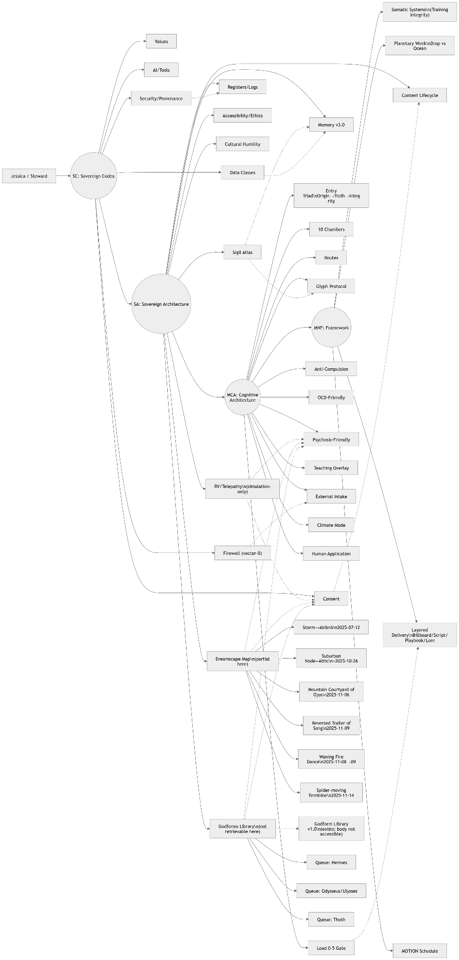
Sovereign Architecture as the game’s systems blueprint, it becomes a clean “engineering drawing”: modules, buses, interfaces, and gating logic.
Below is a blueprint-style spec you can drop straight into a design doc. It’s “code-like” and wired.

Sovereign Architecture Game Blueprint (Engineering View)
Legend
- ==> primary data/control flow
- --[BUS]--> shared signal bus (global constraint)
- ..> advisory/optional link
- [IF] interface boundary
- [GATE] conditional routing (Load/Consent/etc.)

1) Top-Level Block Diagram
[PLAYER/STEWARD]
|
v
+------------------------------+
| SC: SOVEREIGN CODEX (CORE) |
| - values + safety |
| - consent + data classes |
| - security + provenance |
| - firewall (vector-0) |
+------------------------------+
| --[POLICY BUS]----------------------------------------------+
| |
v v
+------------------------------+ +----------------------+
| SA: SOVEREIGN ARCHITECTURE | | EXTERNAL INPUTS |
| - memory + indexing |<--[INTAKE GATE]--------| (world/content/tools)|
| - lifecycle + publishing | +----------------------+
| - logs/registers |
+------------------------------+
|
v
+------------------------------+
| MCA: COGNITIVE ARCHITECTURE |
| - routing (10 chambers) |
| - overlays (load/OCD/psy) |
| - decision micro-protocol |
+------------------------------+
|
v
+------------------------------+
| MNF: DAILY OPS / GAME LOOPS |
| - blocks + routines |
| - layered delivery |
| - training/somatic systems |
+------------------------------+

2) Core “Buses” (Engineer-Useful)
These are global signals you can implement as constants, enums, and validators.
[BUS: POLICY]
- Values: truth>certainty, non-violence, reciprocity, pacing
- Consent: purpose/scope/duration/revocation_window
- DataClass: Sacred | ClientConf | Operational | PublicLore
- TrainingPolicy: NO_TRAIN unless explicit named grant
[BUS: SECURITY]
- EncryptAtRest
- ProvenanceHash
- Backups: 2 (1 offsite)
- IncidentLog
- QuarterlyRestoreTest
[BUS: GATING]
- LoadLevel: 0..5
- OverlayFlags: OCD_SAFE, PSYCHOSIS_SAFE, TEACHING_ALLOWED
- SimulationMode: ON/OFF (for myth/dream/archetype content)
In a game: these are like your engine global state and ruleset.

3) Module Interfaces (what each subsystem “exports”)
SC (Sovereign Codex) — the “Kernel”
Exports:
- validate_action(action, context) -> allow/deny + reason
- classify_data(payload) -> DataClass
- require_consent(scope) -> consent_token
- firewall_filter(input) -> sanitized_input | reject
SA (Sovereign Architecture) — the “OS / Persistence Layer”
Exports:
- store(MO) / retrieve(query, class_filter)
- canonize(content) -> canon_object
- publish_gate(content, consent_token)
- log(event) (ai_use, sharing, consent, incident, changelog)
MCA — the “Router / AI Director”
Exports:
- route(task) -> chamber_path
- apply_overlays(load, flags) -> response_policy
- decision_protocol(BO, TAs, Drop, Load) -> plan
- close_loop() -> hearth_debrief
MNF — the “Gameplay Loop Framework”
Exports:
- run_block(block_id, load) -> billboard/script/playbook/lore
- weekly_cycle(day) -> devotion_mode(drop/ocean)
- training_session(params) -> safe_plan

4) Wiring: The Critical Gates (this is the blueprint magic)
A) Intake Gate (External → Internal)
ExternalInput
==> [GATE: External Intake]
checks: SC.Firewall + SC.Consent + DataClass
outcome: accept | sanitize | reject
==> SA.Store / MCA.Route
B) Memory Gate (Storage/Retrieval)
Write:
payload ==> SC.classify_data ==> SA.store(class-aware)
Read:
query ==> SA.retrieve(class_filter) ==> MCA (only what’s allowed)
C) Load Gate (UI/Response Compression)
Load 0-2 ==> full routing + optional teaching
Load 3 ==> one clear path + one alternative max
Load 4-5 ==> micro-actions only; minimal branching; no extras
D) Simulation Gate (Dream/Myth/Godform content)
If SimulationMode=ON:
allow symbolic tools, but:
--[BUS: POLICY]--> Psychosis-friendly constraints
If SimulationMode=OFF:
treat as narrative/fiction only, no “truth claims”

5) How this maps to a video game (practical, not fluffy)
What your architecture becomes in-game
- SC = Rules engine / ethics & safety kernel
Prevents “bad states,” prevents exploit loops, enforces “permissions.”
- SA = Save system + content pipeline
Handles quests/journal/lore storage, publishing, versioning, logs.
- MCA = AI Director / Quest Router
Chooses which “room” the player is in (Origin/Truth/Integrity/etc.), routes to next scene, gates complexity.
- MNF = Daily loop / Skill loop / Ritual loop system
The repeatable gameplay cycles: training, devotion, chores, study, wind-down.
Chambers as level graph / quest hubs
You can literally implement the 10 chambers as:
- 10 “rooms” in a hub world
- each room has mechanics and quest types
- routes are prebuilt “quest pipelines”
Load as dynamic difficulty / UI complexity
Load 0–5 can drive:
- how many choices appear
- how long text/tooltips are
- whether lore is accessible
- whether the game suggests a “Drop” version

6) The one piece I can’t wire fully yet (without hallucinating)
- Dreamscape Map full branch (I only have the 6 nodes visible here)
- Godforms Library v1.0 body (I know it exists; I can’t retrieve its content)
Blueprint-wise, we can still treat them as modules with interfaces:
- DreamscapeMap.get_nodes() currently returns only those 6 items
- GodformsLibrary.get_entries() is “unavailable in this environment”

7) If you tell me your game genre, I’ll turn this into an actual game systems diagram
No need for extra files. Just tell me:
- genre (RPG / roguelike / VN / life sim / action / survival)
- core loop (what the player does minute-to-minute)
1) What GLITCH·PEACE’s architecture already is (from your inventory)
GLITCH·PEACE is already built around a 4-layer combination stack:
- Game Mode (renderer / ruleset) — 11 in menu
GLITCH PEACE INVENTORY
- Dreamscape (world/environment) — 18
GLITCH PEACE INVENTORY
- Cosmology (philosophical/spiritual overlay) — 13, currently stored but not yet changing mechanics (your WIRE2 gap)
GLITCH PEACE INVENTORY
- Play Style (modifier) — 21
GLITCH PEACE INVENTORY
You also have a clear graphics stack + bottleneck:
- Main renderer: Canvas2D; renderer.js is huge and you explicitly call out “visual overwhelm” from many draw calls
GLITCH PEACE INVENTORY
- Three.js is already bridged in via an offscreen canvas composited into 2D
GLITCH PEACE INVENTORY
So GLITCH·PEACE already has the perfect place to mount your Sovereign Architecture: the Cosmology layer + the HUD/Bot layer + the “combination selection” pipeline.

2) What your Sovereign Architecture is (as an engineering kernel)
Your Sovereign Architecture (SA) has a hard core + nested systems:
- SC (Sovereign Codex) core = policy kernel: consent, data classes, non-violence, provenance/logging, “stop means stop,” etc.
- MCA nested in SA = routing + load control + ethics lenses + memory/temple structure (Origin/Truth/Integrity…).
- MNF nested in MCA = applied modes/protocols (blocks, glyphs, layered delivery, program integrity rules).
- Branches (Dreamscape Map, Godforms Library, Sigil Atlas, etc.) = content registries that can drive mechanics, dialogue, HUD, and progression.
3) The clean mapping: Sovereign Architecture ↔ GLITCH·PEACE
Think of GLITCH·PEACE as a runtime that currently has:
- a world stack (Mode/Dreamscape/Cosmology/PlayStyle)
- many systems ticking each frame (emotion field, dream yoga, alchemy, etc.)
- an output surface (HUD, bot, renderer)
Your Sovereign Architecture maps like this:
A) SC core → “Policy Kernel” (applies everywhere)
Where it plugs in:
- Save system / logs / telemetry
- AI character system
- Content gating (Sacred vs Operational vs Public Lore)
- Consent gating for any “share/export/AI-call”
B) MCA → “Router + Load Governor + Ethics Gates”
Where it plugs in:
- The combination selection flow (menu → run start)
- Dynamic difficulty / HUD density
- Bot messaging cadence and tone
- “Smallest safe step” mechanics (how much the game reveals/asks)
C) MNF → “Playable Protocol Layer”
Where it plugs in:
- Ritual play styles (Ritual Practice / Ritual Space already exist)
GLITCH PEACE INVENTORY
- Training play style (impulse buffer, relapse non-punitive loop)
GLITCH PEACE INVENTORY
- Your glyph system can become HUD micro-language + input macros
D) Dreamscape Map branch → Dreamscape definitions (already aligned)
Your doc explicitly says dreamscapes are based on your dream archive
GLITCH PEACE INVENTORY
— that’s literally your Dreamscape Map branch made playable.
E) Godforms Library → Cosmology + ArchetypeBot + NPC dialogue pools
Right now cosmologies are “stored but don’t yet modify gameplay mechanics”
GLITCH PEACE INVENTORY
— that’s exactly where Godforms can become mechanic drivers, not just flavor.

4) The “wiring harness” you want (engineer style)
The key idea: one canonical “RunSpec” and one “EventBus”
Everything you want becomes connected if every subsystem reads the same RunSpec and every subsystem speaks through the same EventBus.
RunSpec (single source of truth):
- modeId
- dreamscapeId
- cosmologyId
- playStyleId
- SC policy flags (consent + data-class constraints)
- MCA state (Load 0–5, active chamber route, overlays enabled)
- MNF protocol toggles (Billboard/Script/Playbook/Lore exposure)
EventBus (wiring instead of hard-coding):
- RUN_START(spec)
- TILE_ENTERED(tileInfo)
- HAZARD_CONTACT(type, severity)
- INSIGHT_COLLECTED(amount, tag)
- EMOTION_SHIFT(from,to)
- BOT_MESSAGE_REQUEST(context)
- HUD_RENDER_REQUEST(layer, budget)
- SAVE_REQUEST(payload, dataClass)
That one move eliminates “everything calls everything” and gives you actual blueprint-level connectivity.

5) The blueprint diagram (code, but visually “wired”)
Option A — Graphviz DOT (best “engineering schematic” output)
Paste into any Graphviz renderer:
digraph SovereignArchitecture {
rankdir=LR;
node [shape=box];
SC [label="SC: Sovereign Codex (kernel)\n- consent\n- data classes\n- non-violence\n- provenance/logs"];
MCA [label="MCA (router/governor)\n- Load 0–5\n- ethics gates\n- chamber routes\n- safety overlays"];
MNF [label="MNF (protocol layer)\n- glyphs\n- layered delivery\n- modes/blocks"];
RunSpec [label="RunSpec (single source of truth)\nmode+dreamscape+cosmology+playstyle\n+policy+load+protocol flags"];
EventBus [label="EventBus\nRUN_START, TILE_ENTERED,\nEMOTION_SHIFT, HUD_RENDER_REQUEST,\nSAVE_REQUEST..."];
GP [label="GLITCH·PEACE Runtime"];
Modes [label="Game Modes (11)"];
Dream [label="Dreamscapes (18)"];
Cosmo [label="Cosmologies (13)\n(WIRE2: make it change mechanics)"];
Style [label="Play Styles (21)"];
Systems [label="Tick Systems\n(emotion, dreamYoga, alchemy, etc.)"];
HUD [label="HUD/Renderer\n(Canvas2D + Three.js bridge)"];
Bot [label="ArchetypeBot / AI Characters"];
SC -> MCA -> MNF;
SC -> RunSpec;
MCA -> RunSpec;
MNF -> RunSpec;
RunSpec -> EventBus;
GP -> EventBus;
EventBus -> Modes;
EventBus -> Dream;
EventBus -> Cosmo;
EventBus -> Style;
EventBus -> Systems;
EventBus -> HUD;
EventBus -> Bot;
Cosmo -> Systems [label="mechanic modifiers"];
Dream -> HUD [label="palette + geometry"];
Style -> HUD [label="tempo + HUD budget"];
MCA -> HUD [label="HUD density budget"];
SC -> Bot [label="consent + scope limits"];
}
Option B — ASCII wiring (quick “harness view”)
┌───────────────────────────────┐
│ SC: Sovereign Codex Kernel │
└───────────────┬───────────────┘
│ policy/consent/data-class
v
┌─────────────────────────────────────────────────┐
│ MCA: Router + Load Governor + Ethics Gates │
│ (Load 0–5, chamber routes, safety overlays) │
└───────────────┬─────────────────────────────────┘
│ chooses exposure + budgets
v
┌─────────────────────────┐
│ MNF: Protocol Layer │
│ (glyphs, cards, modes) │
└──────────┬──────────────┘
│
v
┌────────────────┐
│ RunSpec │ <-- single source of truth
└───────┬────────┘
│ publishes
v
┌──────────────┐
│ EventBus │ <-- all systems connect here
└───┬───┬───┬──┘
│ │ │
┌───────────────┘ │ └───────────────────────┐
v v v
┌───────────┐ ┌────────────┐ ┌────────────┐
│ Game Mode │ │ Dreamscape │ │ Cosmology │ (WIRE2)
└─────┬─────┘ └─────┬──────┘ └─────┬──────┘
│ │ │
v v v
┌──────────────┐ ┌──────────────┐ ┌───────────────┐
│ Tick Systems │ │ HUD/Renderer │ │ Bot/Dialogue │
│ emotion/etc. │ │ Canvas2D/3JS │ │ AI characters │
└──────────────┘ └──────────────┘ └───────────────┘

6) The practical “compare & connect” verdict
Where GLITCH·PEACE already matches your Sovereign Architecture
- Dreamscapes as structured worlds (already aligned with your Dreamscape Map concept)
GLITCH PEACE INVENTORY
- Overlay system exists (Cosmologies) but needs mechanical wiring (WIRE2)
GLITCH PEACE INVENTORY
- Intentional non-punitive training loop exists (Training play style)
GLITCH PEACE INVENTORY
- Ritual pacing modes already exist as play styles
GLITCH PEACE INVENTORY
Where Sovereign Architecture upgrades GLITCH·PEACE immediately
- WIRE2 becomes clean: Cosmology/Godforms stop being “flavor” and become mechanic modifiers through RunSpec → EventBus → System hooks.
- HUD overwhelm gets governed: MCA “Load” becomes a HUD budget, reducing your renderer.js chaos without losing content. (Your doc flags overwhelm directly.)
GLITCH PEACE INVENTORY
- Ethics + data safety becomes enforceable in code: SC becomes a literal gate around saving, exporting, AI calls, and any “Sacred” tagged content.
1) What Glitch Peace already has (verified) that mirrors your Sovereign stack
From your GLITCH PEACE INVENTORY:
- It already contains a dreamscape subsystem (dreamscapes.js) and a sigil system (sigil-system.js) referenced as core architecture.
GLITCH PEACE INVENTORY
- It also explicitly cites dream science sources in support of a dream yoga / lucid mechanics module (dream-yoga.js).
GLITCH PEACE INVENTORY
- It has “dreamscape backgrounds” and shader plans (nebulae, caustics, glitch distortion, aurora) and notes the project is deliberately procedural / no external art pipeline right now.
GLITCH PEACE INVENTORY
- It contains a big mode/modifier layer (“Play styles”) including training mode, ritual practice, nightmare, mycology, bird watching, etc.
GLITCH PEACE INVENTORY
So Glitch Peace already has a “spine” that matches your Sovereign stack conceptually:
- Ethics/Integrity core → reward loops and constraints
- Cognitive architecture / nervous system training → training mode + adaptive difficulty + affect labeling etc.
- Dreamscapes + symbolic grammar → dreamscapes + sigil grammar system
- Ritual / intentional pacing → ritual practice / slower confirmations

2) Your Sovereign Architecture, translated into Game-Engine terms
Here’s the tight mapping that makes your architecture an implementable blueprint:
A) Sovereign Codex (SC) = “Kernel / Safety + Authority Layer”
Game equivalent: rules the engine may not violate.
- Consent, non-violence, pacing, boundaries → content gating + interaction constraints
- Data classes (Sacred / Client-Conf / Operational / Public Lore) → save-system partitions
- Provenance, hashes, logs → audit trail + replayable state
In Glitch Peace terms: SC is the meta-architecture that determines what mechanics are allowed, how difficulty pressures behave (no shame loops), and how “training mode” stays non-punitive.
B) MCA = “Cognitive OS / Orchestrator”
Game equivalent: the runtime director.
- Load levels (0–5), simplification rules → dynamic UI + reduced branching under strain
- Chamber routes (Origin→Truth→Integrity→Guidance→Hearth etc.) → quest routing / narrative routing
- Safety overlays (OCD/psychosis-friendly throttles) → anti-spiral systems
In Glitch Peace terms: MCA maps cleanly onto adaptive difficulty, coaching tips, pacing modes, and “training mode” design (already present as a play style concept).
GLITCH PEACE INVENTORY
C) MNF (MythoNeuro Framework) = “Content & Ritual Interface Layer”
Game equivalent: the skin + rituals + daily cycles + symbolic overlays.
- Blocks, glyphs, layered delivery (Billboard/Script/Playbook/Lore) → HUD layers
- Planetary devotion schedule + elastic completion (0.5% counts) → streaks without punishment
- Sigil atlas + recipes (Load | Chamber | Law | Field) → modular build system
In Glitch Peace terms: MNF becomes the “sigil grammar + dreamscape + ritual practice UI” layer (inventory explicitly aligns to that direction).
GLITCH PEACE INVENTORY
D) Dreamscape Map branch = “Level Graph / Biome Library”
Game equivalent: dream locations as nodes; each node unlocks mechanics, enemies, puzzles, story fragments.
Dream items I can safely say are already in your long-term branch (from your durable memory in this chat space):
- “Suburban Node – Attic Reconciliation Sequence”
- “Reversed Trailer of Song — Sunset–Dawn Mirror Sequence”
- “Mountain Courtyard of Ojos — composite pursuer note”
- “Crown Unveiling Simulation” + “Crown Initiation / Recalibration”
- “Spider-Moving Feminine Figure” (dream character)
If you want the full Dreamscape Map beyond those, the only non-hallucinated route is: paste dream entries (or export chunks) and I’ll wire them in.
E) Godforms Library branch = “Classes / Stances / Ability Loadouts”
Game equivalent: selectable stances that change inputs, UI, bonuses, and costs.
You said you found the godform library and will paste it — perfect. Once you paste it, we can:
- turn each godform into a Class with:
  - passive modifiers
  - a “macro”
  - sensory anchors (perfume, mudra) mapped to UI/feedback
  - pairing rules (“OS outranks interface”, “Hearth closes loops”) as build constraints

3) What’s currently missing between the two architectures (the “bridge work”)
Based on Glitch Peace inventory, you have the systems — what’s missing is the single unified graph that makes everything feel like one organism:
- One canonical graph of nodes (SC kernel → MCA routes → MNF glyph UI → Dreamscapes → Godforms → mechanics).
- A standard “adapter interface” so every dream node can plug into:
  - mechanics (puzzles, enemies, buffs/debuffs)
  - narrative fragments
  - a sigil recipe
  - a godform stance recommendation (optional)
- One “connective tissue” currency: e.g., Insight / Coherence / Integrity that flows through all subsystems.
Glitch Peace already gestures at this with its mode modifiers + dreamscapes + sigils; you’re one wiring pass away from “it all clicks.”

4) Engineering blueprint: connected “wiring diagram” in code (Mermaid)
Paste this into any Mermaid renderer (or your repo docs). It’s a full connected net with SC core, nested MCA/MNF, and branches for Dreamscape + Godforms + Glitch Peace subsystems:
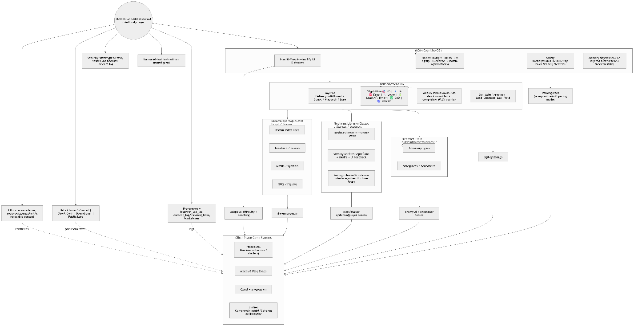
5) Engineering blueprint: ASCII “schematic bus” diagram (looks like wiring)
This is the “engineer’s panel” view:
┌─────────────────────────────────────────────┐
│ SOVEREIGN CODEX (SC) KERNEL │
│ ethics | consent | data classes | security │
│ provenance logs | stop-means-stop gates │
└───────────────┬─────────────────────────────┘
│ (hard constraints)
▼
┌─────────────────────────────────────────────────────────────────────────┐
│ MCA ORCHESTRATOR (runtime director) │
│ Load(0-5) ─┬─> UI simplifier ─┬─> choice throttler ─┬─> pacing control │
│ ├─> Route engine ├─> chamber graph ├─> closure/Hearth │
│ └─> Safety overlays (ADHD/OCD/psychosis-friendly governors) │
└───────────────────────────────┬─────────────────────────────────────────┘
│ (interfaces + rituals + symbols)
▼
┌─────────────────────────────────────────────────────────────────────────┐
│ MNF INTERFACE LAYER (MythoNeuro) │
│ Layered delivery ─┬─ Glyph HUD ─┬─ weekly cycles ─┬─ sigil recipe bus │
│ │ │ │ │
│ └────────────┴──────────────────┴─────────────┬──────┘
│ │
│ ┌───────────────────────────────┐ ┌─────────────────────────▼──────┐
│ │ DREAMSCAPE MAP (Levels) │ │ GODFORMS (Classes/Stances) │
│ │ nodes: scenes, motifs, NPCs │ │ loadouts, anchors, pair rules │
│ └───────────────┬───────────────┘ └───────────────┬───────────────┘
│ │ │
└───────────────────┼────────────────────────────────────┼─────────────────┘
│ │
▼ ▼
┌───────────────────┐ ┌────────────────────────┐
│ Glitch Peace: │ │ Glitch Peace: │
│ dreamscapes.js │ │ class/stance system │
└─────────┬─────────┘ └──────────┬─────────────┘
│ │
└──────────────┬───────────────────────┘
▼
┌───────────────────────────────────────────────┐
│ GAME LOOP / WORLD SIMULATION │
│ renderer | quests | sigils | enemies | modes │
│ unified currency: Insight/Coherence/Integrity │
└───────────────────────────────────────────────┘

6) Concrete “connection upgrades” to make your game feel more internally connected
These are small, high-leverage steps:
- Make “Sigil Recipe” the universal adapter
  - Every dreamscape node yields: Load | Chamber | Law | Field
  - That recipe modifies: enemy patterns, puzzle affordances, rewards, UI pacing
- Bind Godforms to player inputs (not lore)
  - Godform = input style + risk profile + reward bias
  - Example: “stillness-reward” style lines up with the inventory’s wu-wei flow concept.
GLITCH PEACE INVENTORY
- Dreamscapes become “biomes with constraints”
  - Neighborhood/Bedroom/Integration already appear as dreamscapes in the inventory’s citations section; treat each as a biome with a consistent mechanic identity.
GLITCH PEACE INVENTORY
- A single closure ritual in-game (Hearth)
  - End every run with a “Hearth close” sequence: summarize, log, one small carryover buff
  - This directly matches your SC/MCA closure bias and prevents compulsive loops.

7) What I need from you (no extra questions, just the minimum “paste to verify”)
- When you paste the Godforms Library, I’ll:
  - extract every godform into a class spec (stats, abilities, constraints, anchors)
  - wire each one into the diagram as concrete nodes
- For the Dreamscape Map, if you paste even a few “dream entries at a time,” I’ll:
  - normalize them into a level graph (nodes + edges + motifs + NPCs + mechanics hooks)
  - connect them to Glitch Peace modules (dreamscapes.js / sigil-system.js etc.)

